**OOPs Concept (Object Oriented Programming):-**

#. It is a technique to design a program using classes and objects.

#. 4 Major pillar of OOPs Concept.

1. Inheritance

2. Polymorphism

3. Encapsulation

4. Abstraction.

1. Inheritance

#. It is a mechanism in which child class acquires the property of parent class.

#. Advantage : Code Reusability.

#. The class which inherits the properties of other class is known as child/derived/sub class.

#. The class whose properties are inherited is known as parent/base/super class.

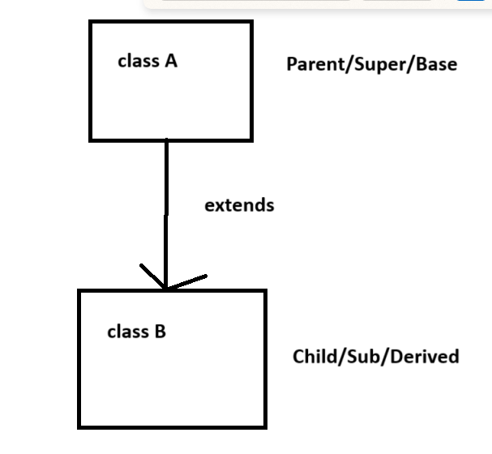

**Types of Inheritance:-**

**1. Single Inheritance**

**2. Multilevel Inheritance**

**3. Hierarchical Inheritance**

**4. Multiple Inheritance- is supported through interface**

**5. Hybrid Inheritance- is supported through interface**

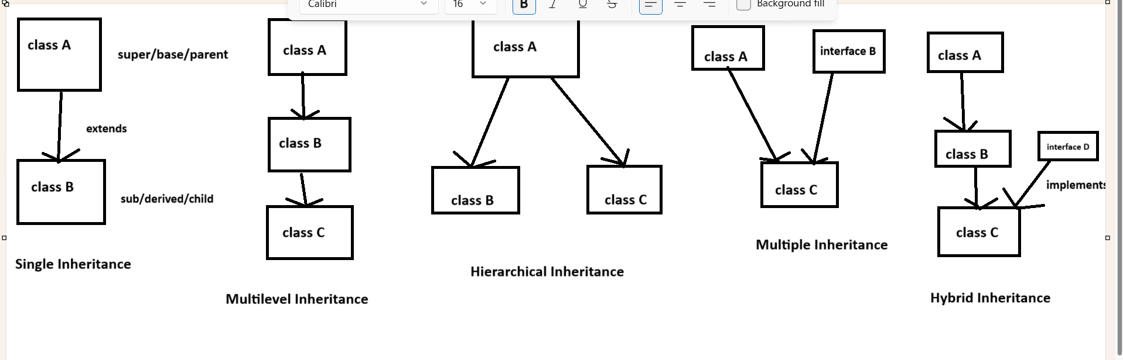

**Polymorphism:-**

**#. When we perform one task in multiple ways , that is known as polymorphism.**

**1. Method Overloading/ CompileTime Polymorphism.**

**2. Method Overriding / RunTime Polymorphism.**

**1. Method Overloading:- In case of Method Overloading, Method name will be same but parameter will be different.**

**2. Method Overridding :- In case of Method Overridding, Method name and parameter both will be same.**

**Abstraction:-**

**#. It is the process of hiding the implementation of code and showing only the functional behaviour.**

**#. We can have abstract class, abstract method etc.**

**#. will use abstract keyword to deal with abstraction.**

**#. By the help of abstraction we can achieve 0 to 100% abstraction.  
#. We can have abstract as well as non abstract method in a class.**

**Interface:-**

**#. It is also the process of hiding the implementation of code and showing only the functional behaviour.**

**#. Will use interface keyword to deal with interface**

**#. By the help of interface we can achieve 0 to 100% abstraction.**